Packet Tracer – Using the Cisco IOS Show

1. Topology

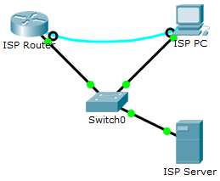

1. Objectives

* Use the Cisco IOS **show** commands

1. Background / Scenario

The Cisco IOS **show** commands are used extensively when working with Cisco equipment. In this activity, you will use the **show** commands on a router located at an ISP.

* + 1. Connect to the ISP Cisco 1941 router.

In this step, you will use the terminal emulation software on ISP PC to connect to the Cisco 1941 router.

* + - 1. Click **ISP PC**.
      2. Click **Desktop** tab. Select **Terminal**. Review the terminal configuration and click **OK** to continue.
      3. The **ISPRouter >** prompt indicates that you are in user EXEC mode. Press Enter if the prompt did not display.
    1. Explore the show commands.

Use the information displayed by these **show** commands to answer the following questions.

* + - 1. Type **show arp** at the prompt.

Record the MAC address and the IP address listed. Type **show flash** at the prompt.

Record the IOS image listed: Type **show ip route** at the prompt.

How many routes are listed in the table? Type **show interfaces** at the prompt.

Which interface is up and running?

|  |  |  |
| --- | --- | --- |
| Interface | Status | Protocol |
| GigabitEthernet 0/0 | Up |  |
| GigabitEthernet 0/1 |  | Down |
| Serial0/1/0 |  |  |
| Serial0/1/1 | Down |  |

* + - 1. Type **show version** at the prompt.

What technology package is enabled currently on the router? Type **show ?** at the prompt. List a few more **show** commands that are available in the user EXEC mode.

____________________________________________________________________________________

____________________________________________________________________________________

* + - 1. Enter **enable** at the prompt to enter the privileged EXEC mode. List some additional **show** commands in this mode.

____________________________________________________________________________________

____________________________________________________________________________________